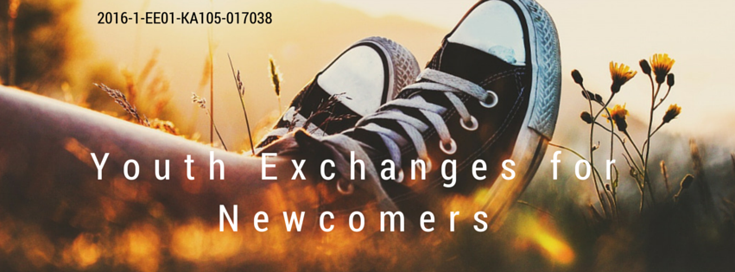

Contact-making event „Youth Exchanges for Newcomers “
15st-22nd of August 2016. Pärnu, Estonia
APPLICATION FORM
This application form should be completed by EACH participant and sent by e-mail to info@noorusemaja.ee
!!! The deadline for submission is 22nd of May 2016!!!

Personal Details
Name(-s)
Surname
Date of Birth
Gender
Mobile phone (with international code)
E-mail
Home address
Facebook-Name
Citizenship

Personal and Professional background
The name of organization that you are currently most actively involved in and will be representing during this training.
Main activities that the organization does.
Do you have any experience of participating in projects in the framework of the Erasmus+ / Youth in Action Programme? Also YOUTH EXCHANGES...(if you don’t have don’t worry, this is a project for NEWCOMERS :))
Who are the young people with whom/for whom you would like to develop some youth exchange during this contact-making event?
Should there be such a need, do you think that your organization would be able to APPLY for the youth exchange project to your National Agency and take the responsibility of coordination? Do you have the support for prarticipation in this project from your organization?
If you already have any ideas, what are the topics/themes that you would be interested to develop the youth exchange project on?
Any other comments...

Special Needs, Emergencies, Conditions
Special Needs or Requirements:
- Please let us know if you require any special arrangements or if there are things we need to be aware of (vegetarian, allergies, impediments, ...): I would prefer vegetarian food if possible.

Please indicate the name and full contact details of a person to be contacted in case of emergency during the training course:
Name
Complete address
Postal code |  | Country
Phone
[with full international dial codes]
E-mail

CONDITIONS: Please take note of the following conditions that will apply as you send this application form and will take part in the training course:
- I have read carefully the practical information regarding the seminar and am aware about the conditions of participation in the training course.
- I commit myself to participate in the whole process, including:
- to prepare myself carefully for the training course and to do all remote preparation work the team will ask for (for example, “ home work”),
- to take part in the full duration of the training course
- to participate in the whole evaluation process
- I am aware that obtaining a health and a full travel insurance are my own responsibility and at my own expenses. I understand that the information I provided on my special needs does not remove my own personal responsibility for ensuring my own health.
- If I cancel my participation, I abide myself to inform about it immediately so the organizers can find a suitable replacement.
Contact
We look forward to your early reply. For inquiries and additional information, please contact:
Project coordinator Uudo Laane – info@noorusemaja.ee +372 5143726
!!! The deadline for submission 22.nd of May 2016!!!

In case you are not able to attend some session due to health reasons, please immediately inform about that the organizers. In case of skipping parts of the programme without informing us on that, participants will not be reimbursed the travel expenses.

