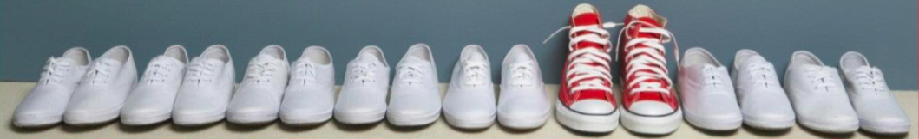

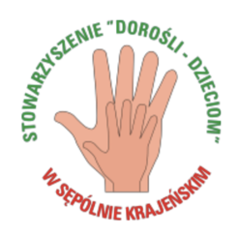

"Youth exchange for newcomers
15-22 of August, 2016 Pärnu,Estonia

„HOME-WORK” – tasks to do BEFORE coming to ESTONIA

Dear participants of the project!

We are very glad that our contact-making activity is coming closer and closer and we will have the chance to meet you all very soon in Pärnu. To make sure that we make the best out of this experience, we would like to ask you to devote some time to prepare for it before coming.

To check-in for the activity, please read the below-mentioned “home-work” tasks and do them.

- WHAT EXACTLY DO YOU WANT TO “GET OUT” OF IT?
As this is activity will be a chance for you to learn a lot of new things, please spend some time to answer some questions on what is it that you would like to get out of it:
What is the REAL reason why I decided to come and participate in this activity?
Why am I interested in Youth Exchanges?
How can participation in this activity be beneficial to the organization I work with and young people?
How can I contribute to make this activity a success? What am I ready to share?
How would I like to challenge myself during this activity and in which way to get out of my comfort zone?

Knowing what you want to achieve is one of the crucial keys to manage to reach it! Remember that your learning starts already NOW!

May be you know about it already, but if not, please check out some information about Youthpass: https://www.youthpass.eu/en/youthpass/about/process/

As in every mobility, also in this on you will be able to receive the Youthpass certificate – if you take the challenge to observe your learning process and recognize what you have learnt.

- FIND OUT MORE ABOUT THE ACTIVITY AND THE PARTICIPANTS THROUGH FB
For the purpose of sharing the information about this activity and getting to know each other, we have created a group: https://www.facebook.com/groups/1754157771507545/?fref=ts
Please have a look at it and use the opportunity to introduce yourself to others. You can also share some links/videos that show the work of your organization. Start NETWORKING!

- FIND OUT MORE ABOUT YOUTH EXCHANGES
No secret that a lot of information about Youth Exchanges is “out there” already. Not to start our activity from “zero”, we expect you to check out some of the information.

- Watch at least 3 videos about youth exchanges
https://www.youtube.com/watch?v=myhRLRrV8Io&list=PLKzHKzqsYagcBDZlX6pMdiNpkDFPCmX9J

- Have a look at least 1 guidebook on how to make youth exchanges (you don’ t have to read it all page by page, but just go through it..)
“Ready to (ex)CHANGE! Practical Guide for Youth Exchange Organizers”
http://jtba.lt/biblioteka/be-ready-to-exchange-practical-guide-for-youth-exchange-organisers/
“Cherry on the Cake. Advice for Quality Planning of Youth Exchanges”
https://www.salto-youth.net/downloads/4-17-3198/Cherry%20on%20the%20cake%20%20publication.pdf

- Have a look at either guidelines or Prezi summary of Erasmus+ programme: Youth in Action
Erasmus+ Guidelines
https://www.salto-youth.net/downloads/4-17-2904/PG_EECA_excerpt_en.pdf
Summary about Erasmus+ in Prezi
https://prezi.com/g-b-6zxdpayv/erasmus-leargas/

- WHAT KIND OF YOUTH EXCHANGE WOULD YOU LIKE TO “BRING HOME”?

As this partnership building activity aims to involve all the participants in developing some youth exchange idea that could later on be implemented, one of the most important things – take a time to discuss ideas what kind of youth exchange idea they would expect you to “bring home” with representatives of your organization and young people that would be interested to get involve.

Before coming to Parnu (there will be NO time for it during the activity!) prepare the poster sharing the following contents:

About organization
- Organization name (and logo), country and city
- Your name and role in organization
- 5 keywords of what your organization does
- Some pictures from activities that you have done
- Target groups that you generally work with
- What is special/unique about the organization?

About Youth Exchange
- More details about young people that would like to/could involve in the youth exchange you will be developing (their interests and needs, talents and topics they care about)
- Selfie of you and the members of your organization including people that will also be involved in youth exchange later on
- What could be the themes of youth exchanges your organization would be interested to work on (if any preferences)
- How could members of your organization and young people be involved in youth exchanges (what support could they provide?)
- Could your organization take the responsibility of hosting the youth exchange in your community or applying & coordinating it (only for Erasmus+ Programme countries)?

- NATIONAL COFFEE BREAKS

During the project we will have some tea breaks and some coffee breaks. To make them more diverse and interesting and at the same time discover something special about the food from your country/region, we would like to ask the delegations of each country to contribute to one of the tea/coffee breaks (for example, Polish coffee break…). Please bring with you some snacks, sweets and soft drinks that could be shared with others.

(Generally, we do not plan to organize a traditional Intercultural evening with each country presenting itself, but if you feel like sharing with the others also some alcoholic beverages at some of free evenings, surely you can take it with you…)

Greetings,

Your team – Uudo, Julien, Antonio and Ieva

